Lab 5:

***kubectl get nodes***

***kubectl describe nodes ubuntu20***

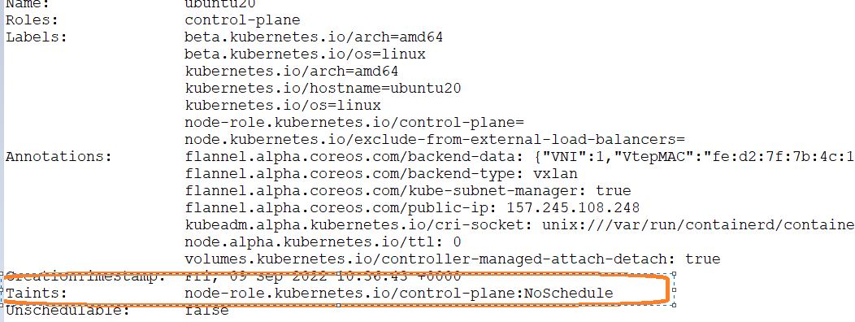

***kubectl taint nodes ubuntu20 node-role.kubernetes.io/control-plane:NoSchedule-***

